# HMS

## Introduction

The NavVision HMS is configured according the CAP437 and CAP746 standards. It is the world’s first HMS that is actually working exactly according rules and is beautiful to look at. It has all the data right at hand where you want it and it is easy to see all the important data at a glance. Besides that it can generate a report that can be in raw data (as most pilots like it) and decoded. This way both professionals and other labor can work with the report easily. The report can be send to anyone through email or can be printed. In the near future it will be possible to make the data available for a larger group through web service.

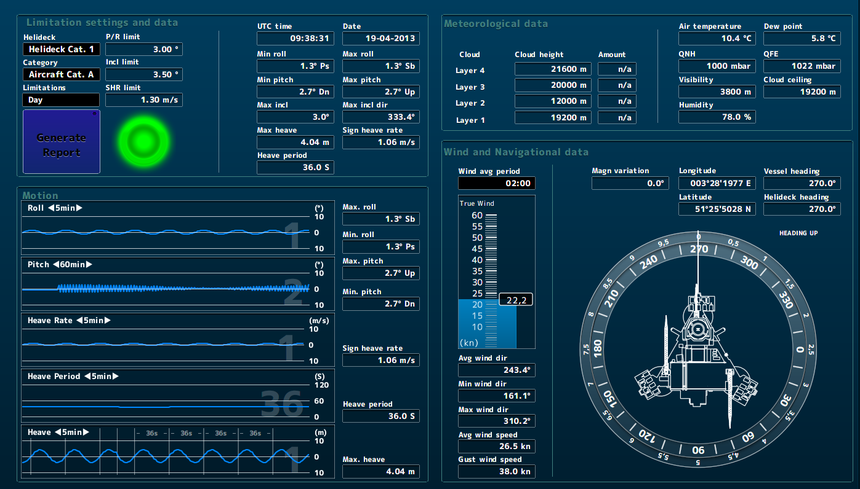

Figure 1‑1: NavVision HMS

## The groups

The HMS mimic is divided into four groups. This to make it more distinct where you are looking at. These four groups are:

* Limitation settings and data
* Motion
* Meteorological data
* Wind and navigational data

## Limitation settings and data

This section is meant for the overall settings of the limitations. You can imagine that you can land a helicopter during daytime with higher deviations then during nighttime. However, CAP437also provides different helideck categories and different aircraft categories that will alter the limitations. These settings can be done here. You can also see directly what the limitations are for the settings and you can see the actual values (see Figure 1‑2).

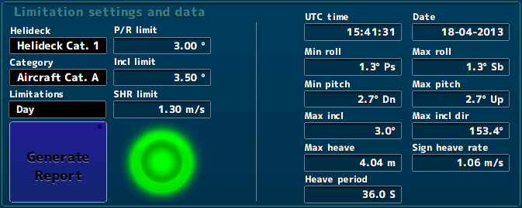

Figure 1‑2: Limitation settings and data

The “limitation settings and data” section consists of the following fields:

|  |  |
| --- | --- |
| Field | Explanation |
| Helideck | Choose the Helideck type category |
| Category | Choose the Aircraft type category |
| Limitations | Choose between day or night |
| P/R limit | Pitch and roll limits depending on settings |
| Incl limit | Inclination limit helideck depending on settings |
| SHR limit | Significant Heave Range limit depending on settings |
| Generate report | Generate a report for flight preparation |
| Light | Green means within limit, red means beyond limits |
| UTC time | Uniformed Time Coordinated (Old GMT) |
| Date | Date |
| Min roll | Minimum Roll during past 20 minutes |
| Max roll | Maximum Roll during past 20 minutes |
| Min pitch | Minimum Pitch during past 20 minutes |
| Max pitch | Maximum Pitch during past 20 minutes |
| Max incl | Maximum Inclination during past 20 minutes |
| Max incl dir | Maximum Inclination Direction during past 20 minutes |
| Max heave | Maximum Heave during past 20 minutes |
| Sign heave rate | Significant Heave Rate during past 20 minutes |
| Heave period | Period between highest and lowest heave |

Table 1‑1: Limitation settings and data

### Limitation settings

In CAP437 there are a few different situations that you need to choose. These settings are the type of helideck, the type of aircraft and if it is day or night. Depending on these settings the limitation settings will change.

When you click on the Helideck value bar you get a window where you can choose which type of helideck the installation is installed on (see Figure 1‑3).

When you click on the category value bar you get a window were you can choose which type of aircraft category the report is meant for (see Figure 1‑4).

When you click on the limitations value bar you can choose whether it is day or night (see Figure 1‑5).

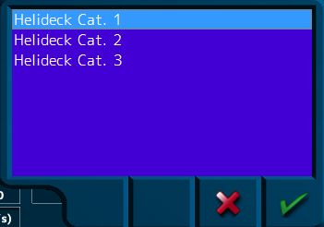

Figure 1‑3: helideck choice

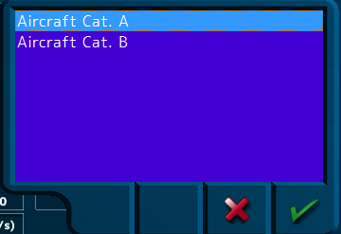

Figure 1‑4: Aircraft choice

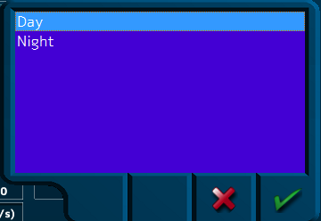

Figure 1‑5: Limitation choice

Depending on your choices you will get different limitations. Each category of helideck and aircraft as well as the difference between day and night, will change the limitation settings. The combination of these three settings is crucial for the operation of the HMS.

Next to the settings you will see for each combination what the max pitch and roll is as well as the max inclination of the helideck and the significant heave rate limit (see Figure 1‑6).

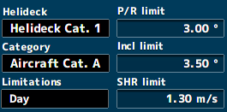

Figure 1‑6: choices with limits

### Generate report

To be able to send a report to third parties that rely on this information, there is a button that you can click to generate a report. Once clicked it opens a new window (see Figure 1‑7).

In this window you fill in the recipients mail address.

While lightning is a very important weather type. You can directly click on the “lightning present” checkmark if you need to.

Underneath you can choose multiple phrases that refer to the present weather conditions. To select multiple choices, just hold the CTRL key.

After you have done all this, you click the green checkmark and the report will be generated (see Figure 1‑8).

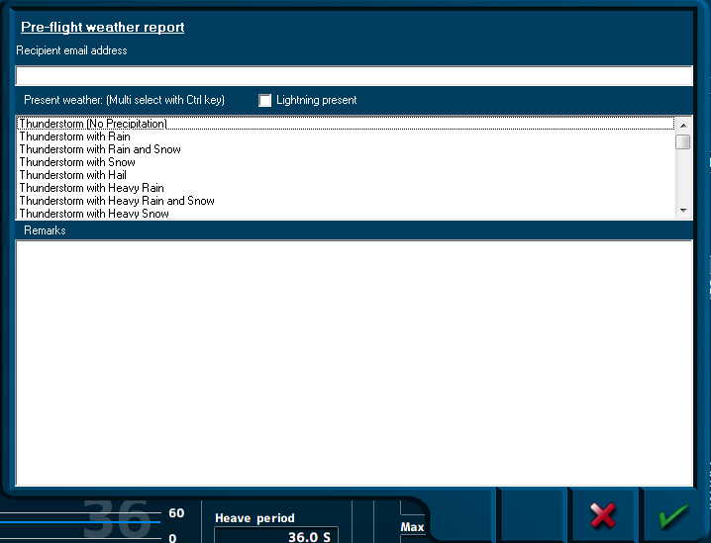

Figure 1‑7: generate report window

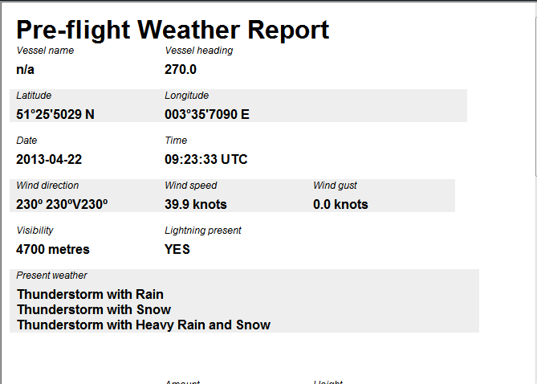

Figure 1‑8: Pre-flight weather report

### Light

The light simply shows if the helideck is within limits. Red means that the helideck is out of limits and traffic will not be possible. Green means that the helideck is within limits.



*: The HMS is merely a platform to show all the relevant data. It is always up to the crew on the platform and the aircraft pilots to make the decision if it is safe to maneuver.*

### Data

Most of the data fields show the average data over the past 20 minutes (see Figure 1‑9).

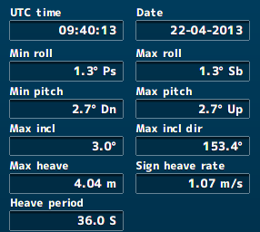

Figure 1‑9: Limitation data

UTC time and Date speak for itself. The rest of the fields are taken over a period of 20 minutes to show the average roll, pitch, inclination and heave data. For explanation we refer you to Table 1‑1.

## Motion

The “motion” section is meant to give you the real-time data for the most important values (see Figure 1‑10). The real-time data is presented in graphs that are situated on the left side. These graphs have the opportunity to change the time range so you can see the real-time information over different periods of time. The range runs from 1 minute to 2 hours (see Figure 1‑11 and Figure 1‑12). This gives you the opportunity to see a kind of trending.

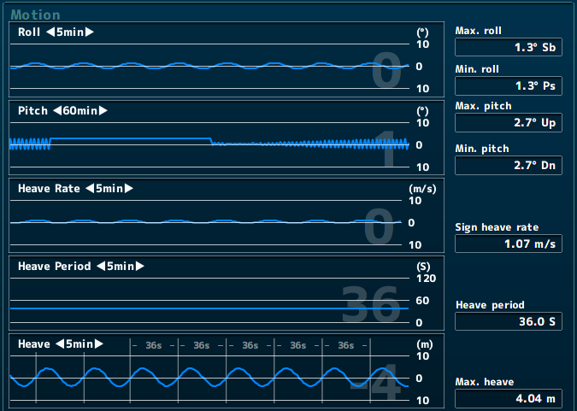

Figure 1‑10: Motion section

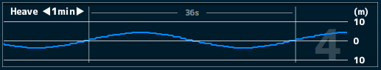

Figure 1‑11: Heave 1 minute setting

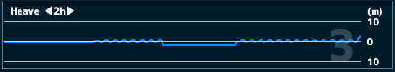

Figure 1‑12: Heave 2 hour setting



*:no matter what time range you choose, you can always see the actual value as a number on the right side of the graph (see* Figure 1‑13*).*



Figure 1‑13: Actual value graph

### Average values

Next to the graphs are the same average values as in the “limitation settings and data” section. This time they are lined up with their own graph for your convenience. For explanation see Table 1‑1.

## Meteorological data

The section shows, as the title says, meteorological data. This is all weather data that a pilot will need to plan the flight (see Figure 1‑14). It consists the following data (see Table 1‑2).

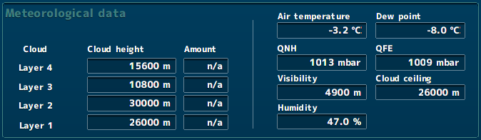

Figure 1‑14: Meteorological data section

|  |  |
| --- | --- |
| Field | Explanation |
| Cloud | Defines one of the four layers of clouds |
| Cloud height | Shows the distance between the clouds base and the top |
| Amount | Show how much cloudiness there is (FEW/SCT/BKN/OVC) |
| Air temperature | Actual outside ait temperature OAT |
| Dew point | Dew point temperature |
| QNH | Atmospheric pressure, Corrected to mean sea level |
| QFE | Atmospheric pressure at sea level |
| Visibility | Visibility measured in distance |
| Cloud ceiling | The lowest base of the clouds |
| Humidity | Humidity in percentage |

Table 1‑2: Meteorological data explanation

### Cloud height

The cloud height is the distance from the base of clouds (or cloud ceiling) and the top of the clouds in a certain layer. These layers are approximately divided into different zones due to international rules.

It is very important to know the height of clouds. High clouds are primarily composed of ice crystals; Medium clouds are a mixture of water droplets (usually super-cooled) and ice crystals, in varying proportion, and low clouds primarily water droplets.

Cloud height is often related to the intensity of precipitation generated by a cloud: deeper clouds tend to produce more intense rainfall. For instance, cumulonimbus clouds can develop vertically through a substantial part of the troposphere and often result in thunderstorms with lightning and heavy showers. By contrast, very thin clouds (such as cirrus clouds) do not generate any precipitation at the surface.

In the 'Low' cloud classification come: Stratus (St); Stratocumulus (Sc); Cumulus (Cu) and Cumulonimbus (Cb). However, note that both Cumulus and Cumulonimbus clouds often extend well into 'medium' levels, and towering Cu, and Cb extend to 'high' levels.

In the 'Medium' cloud class come: Altostratus (As); Altocumulus (Ac) and Nimbostratus (Ns). Nimbostratus often has a base within the 'low' cloud category.

In the 'High' cloud group are: Cirrus (Ci); Cirrocumulus (Cc) and Cirrostratus (Cs).

### Amount

Cloud cover (also known as cloudiness, cloudage or cloud amount) refers to the fraction of the sky obscured by clouds when observed from a particular location.

The amount of the sky that is obscured is defined in octa. So if there are no clouds the sky is 0/8 obscured. The following amounts are available”

* FEW sky is obscured form 1/8 to 2/8
* SCT sky is obscured from 3/8 to 4/8
* BKN sky is obscured form 5/8 to 7/8
* OVC sky is completely obscured 8/8

The abbreviations stands for the following, to make it easier to understand.

* Few Few
* SCT Scattered
* BKN Broken
* OVC Overcast

### Air temperature and dew point

These two temperatures are used in close combination. The air temperature is the Outside Air Temperature (OAT) on the location. This is already important for the pilot while they need to know if the OAT is low or below zero with reference to carburetor icing.

The relationship between dew point and temperature defines the concept of relative humidity. The dew point, given in degrees, is the temperature at which the air can hold no more moisture. When the temperature of the air is reduced to the dew point, the air is completely saturated and moisture begins to condense out of the air in the form of fog, dew, frost, clouds, rain, hail, or snow.

The closer the OAT is to the Dew point temperature, the more certain is the change that one of these phenomenon’s will occur at low heights.

### QNH and QFE

QNH - when this pressure is set on your altimeter it will give you your altitude above mean sea level in your area. As all aeronautical charts show elevation in feet amsl this is the one to use to make sure you're going to be above terrain or obstacles (such as TV masts).

QFE - with this set your altimeter will read 0ft on landing. It gives you your height above the airfield for which that particular pressure is valid. At your stage of the game you might want to set this for flying in the circuit so that you can fly at circuit height

## Wind and navigational data

In this section of the HMS you can find all the information on wind and navigation. It has a wind section on the left and a navigational section on the right. Wind speaks for itself. The navigational data is to prepare for the place and direction of the helideck (see Figure 1‑15).

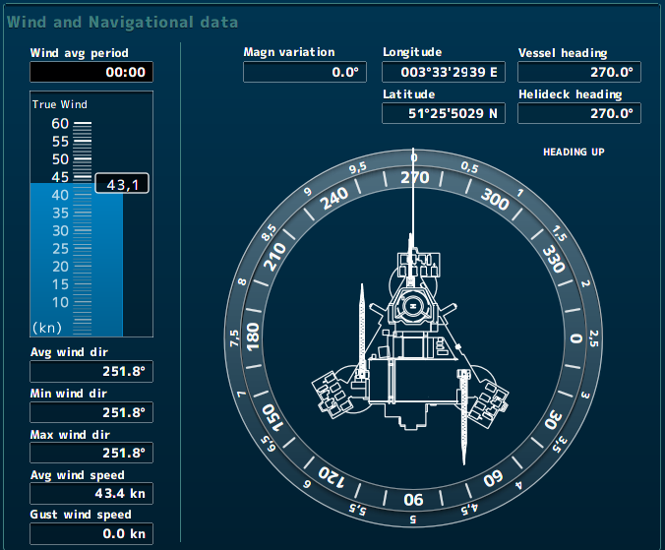

Figure 1‑15: Wind and navigational data

### Wind

Wind is a very important variable for the pilot to prepare the flight. In particular the wind speed and the gust wind speed are important. The explanation of the fields are as follows:

|  |  |
| --- | --- |
| Field | Explanation |
| Wind avg period | Setting of period for measuring average wind values |
| True wind | True wind real time |
| Avg wind dir | Average wind direction over a set amount of time |
| Min wind dir | Minimal wind direction over a set amount of time |
| Max wind dir | Maximal wind direction over a set amount of time |
| Avg wind speed | Average wind speed over a set amount of time |
| Gust wind speed | Gust wind speed over a set amount of time |

Table 1‑3: Wind explanation

Except for the true wind, all the other wind values are depending on the time you have set in the field “Wind avg period”. When you click on this field you will get a pop-up window where you can choose different period (see Figure 1‑16).

* Real time Real time values
* 2 minutes Average values over the past 2 minutes
* 10 minutes Average values over the past 10 minutes
* 20 minutes Average values over the past 20 minutes

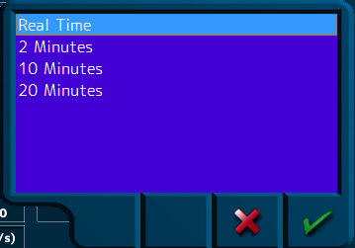

Figure 1‑16: Average wind period choice

### Navigational data

As mentioned before the navigational data is to prepare the flight. You need to know where the helideck is to plan your flight. Also you need to now the heading of the helideck (if applicable) to now your entrance. Therefor we have a few values and a compass to show how and where the helideck is positioned.

|  |  |
| --- | --- |
| Field | Explanation |
| Magn variation | Magnetic variation on that spot |
| Longitude | specifies the east-west position of a point on the Earth's surface |
| Latitude | specifies the north-south position of a point on the Earth's surface |
| Vessel heading | The heading of the vessel or object that contains the helideck |
| Helideck heading | The heading of the helideck itself |
| Compass | Visualization of the helideck in a true compass |

Table 1‑4: Navigational data explanation

The magnetic variation is a given deviation that changes every year. It can be found on sea maps and flight maps.

If the helideck is on a vessel it is nice to know the position of that vessel. You can use the latitude and longitude to find the ships position.

For your approach you need to know the heading of the vessel. Mostly you can only approach it from one direction, so knowing the vessels heading gives you the opportunity to plan your approach. If the heading of the helideck differs from the vessels heading, it is most likely that the helideck is on another position of the vessel than the bow. Or even not aligned with the vessel at all. This is also important for your approach planning.

You can change the compass into “heading up” and “north up” by clicking on one of these words at the top right of the compass (see Figure 1‑17).

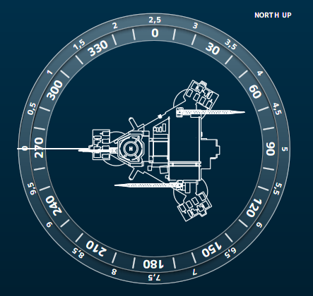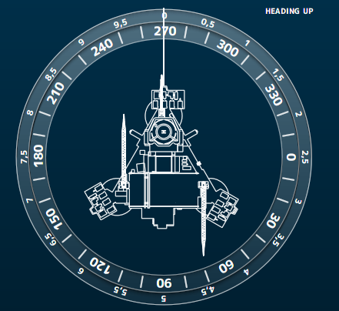

Figure 1‑17: Compass north up and heading up